Airkrit India Pvt. Ltd.  D-160, Dwarka, New Delhi – 110075  CIN - U85499DL2023PTC423549  www.airkrit.com  support@airkrit.com  +91 8929252575 | 

Certificate
DD-MM-YYYY
Dear [Your Name]
ID : AI-XXXX
TO WHOM SO EVER IT MAY CONCERN

This is to certify that [Full Name] has successfully completed the [Course Name] offered by Airkrit India. Through this program, they have acquired essential skills in [Key Topics or Technologies], demonstrating commitment to learning and professional growth.
During the course, [Full Name] engaged actively with our structured curriculum, including live sessions, mentorship interactions, and self-paced content. The training emphasized practical application of concepts, preparing them for future opportunities in the tech industry.
We acknowledge their dedication and performance, and wish [Full Name] continued success in applying these newly gained skills toward a rewarding career in technology.

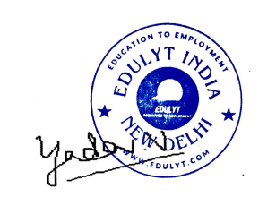
[%qrImage]
Vishal Yadav – Manager HR

Edulyt India
Education to Employment

Note: Future verification can be done on verify@airkrit.com

